Project Report

1. **INTRODUCTION**
   1. Overview

* Wholesaling or distributing is the sale of goods  to retailer to industrial, commercial, institutional or other professional businessman to other wholesalers (wholesale businesses) and related subordinated services.  Wholesaling is buying goods in bulk quantity, usually directly from the manufacturer or source, at a discounted rate. The retailer then sells the goods to the end consumer at a higher price making a profit.
* The consumption and production of marketed food are spatially separated. Production is primarily in rural areas while consumption is mainly in urban areas. In today's highly competitive business landscape, gaining deep market insights is essential for businesses to thrive and grow. This project aims to analyze customer spending behavior and identify opportunities for growth by leveraging data analytics and data-driven decision-making.
* The primary objective of this project is to understand customer spending patterns, preferences, and trends across various dimensions. By conducting a comprehensive analysis, businesses can optimize their marketing strategies, improve product offerings, and enhance customer engagement to drive revenue growth.
  1. Purpose
* The Purpose of the field of market insights is to learn about and analyses the market. Data on the market, consumers, and competitors must be gathered, analyses, and interpreted by individuals in this role. Their main objective is to give important information and viewpoints to company decision-makers, helping them to make wise decisions and create plans.

1. **Problems definition & design thinking**
   1. Empathy Map

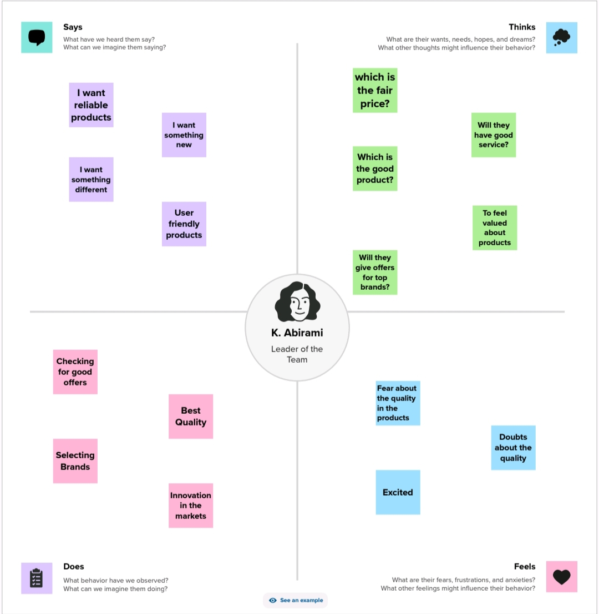

2.2 Ideation & Brainstorming map

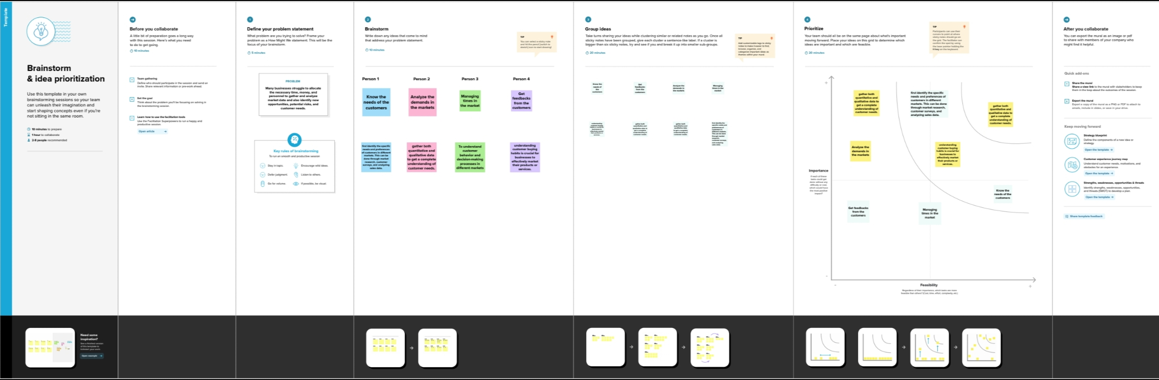

1. **DATASET**

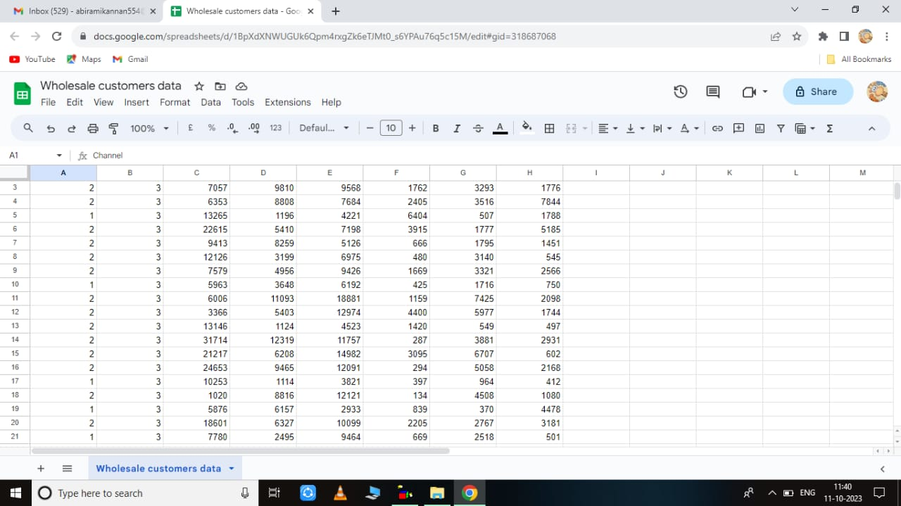

**4.VISUALIZATIONS**

4.1MILK KPI:

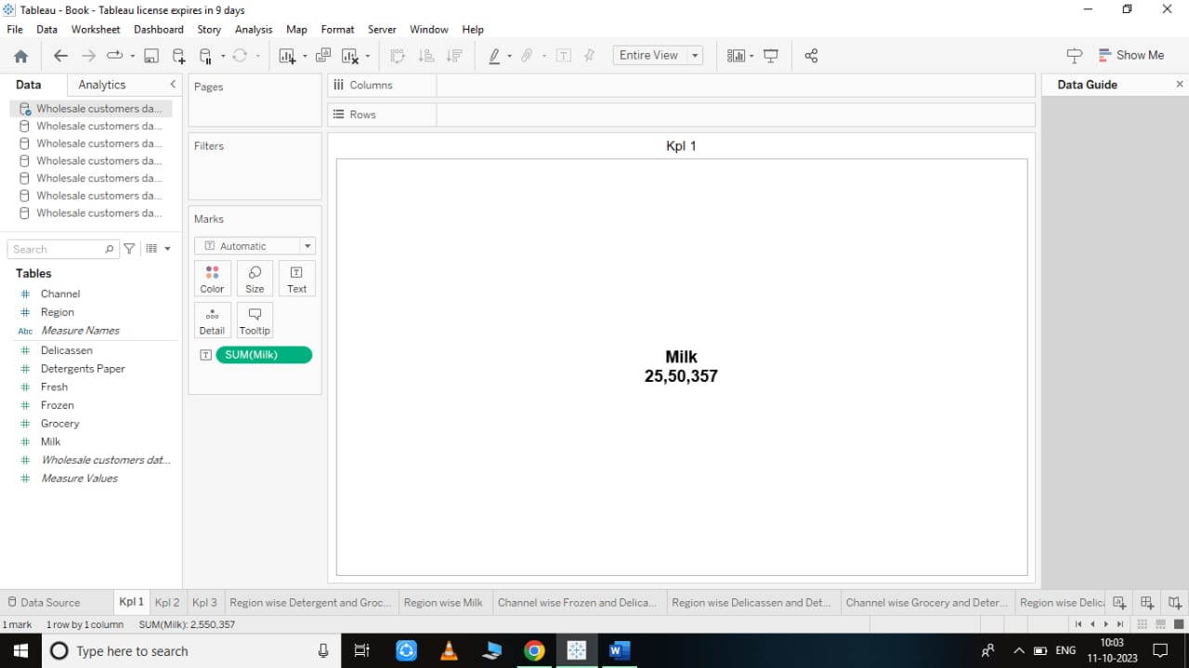

4.2 GROCERY KPI:

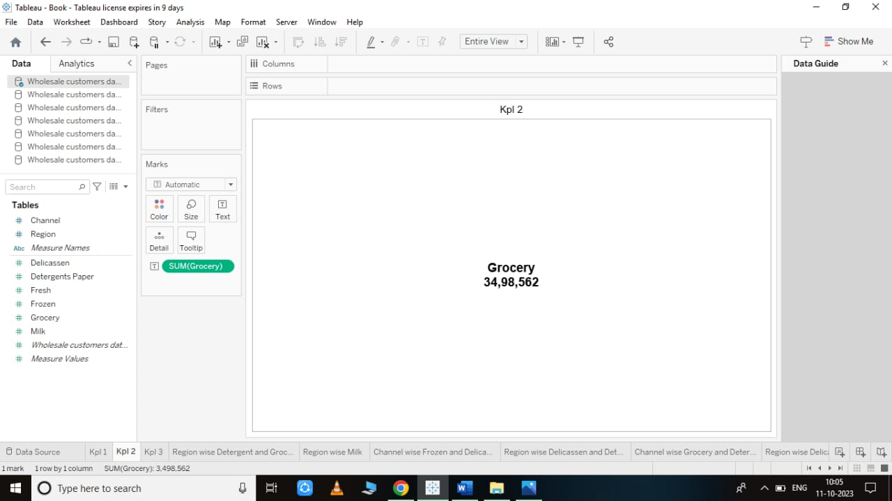

4.3 FRESH KPI:

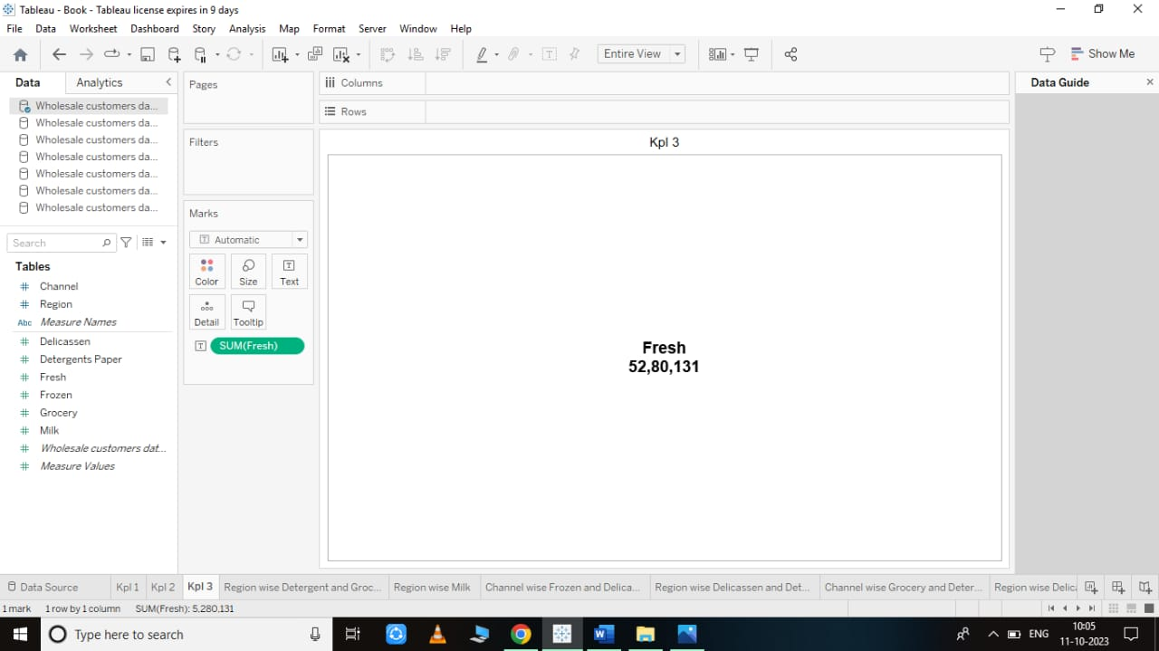

4.4 REGION WISE GROCERY AND DETERGENT PAPER:

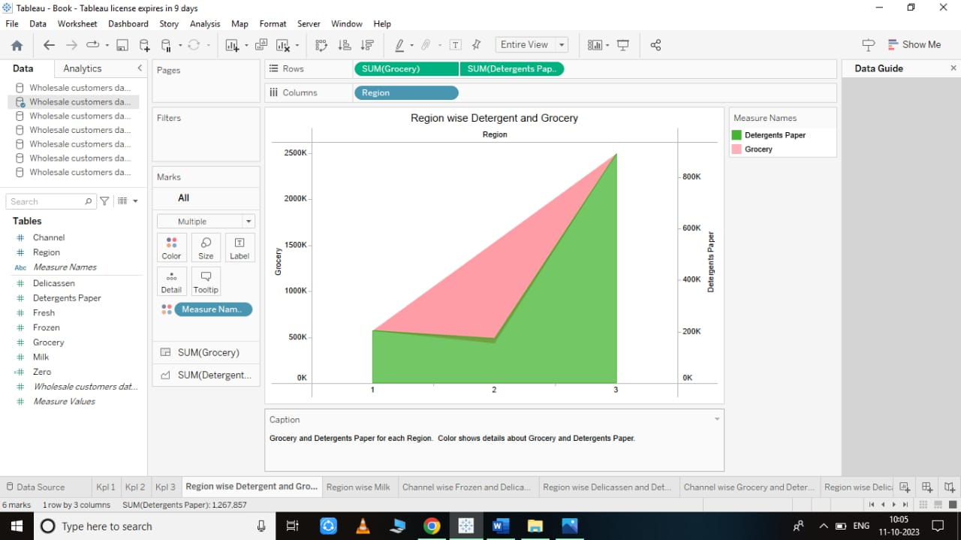

4.5 REGION WISE MILK:

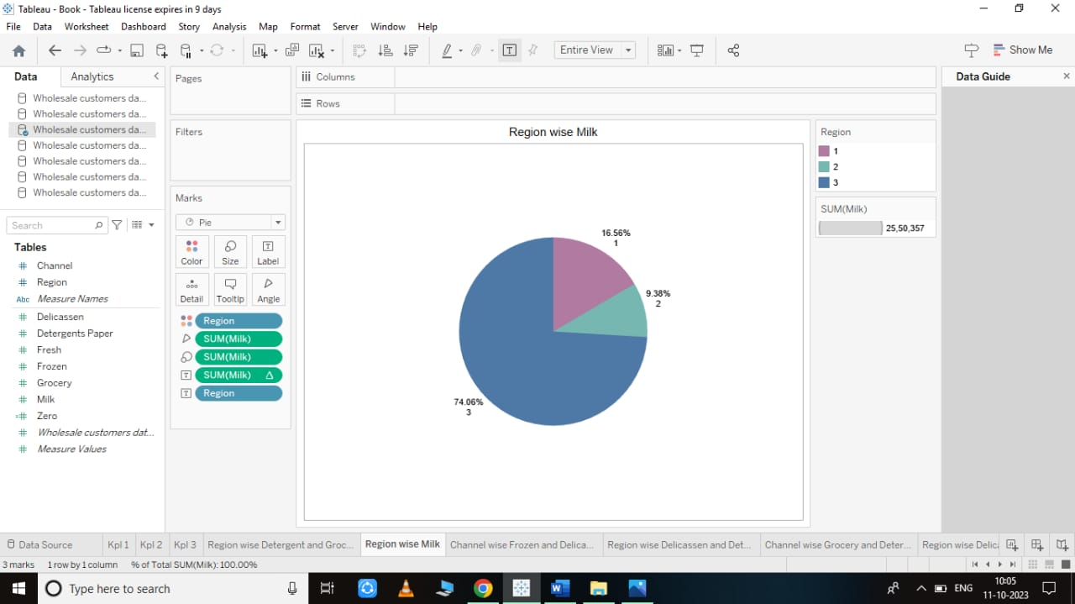

4.6 CHANNEL WISE DELICASSEN AND FROZEN:

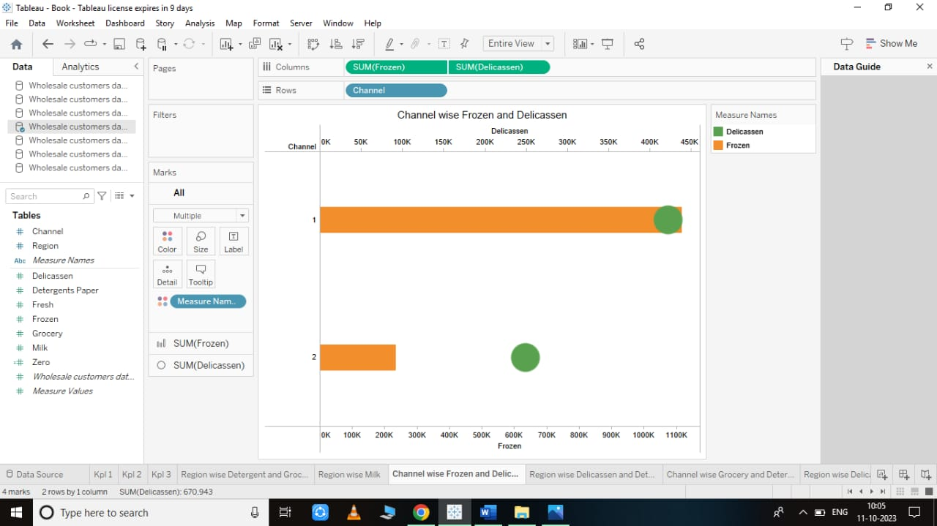

4.7 REGION WISE DELICASSEN AND DETERGENT PAPER:

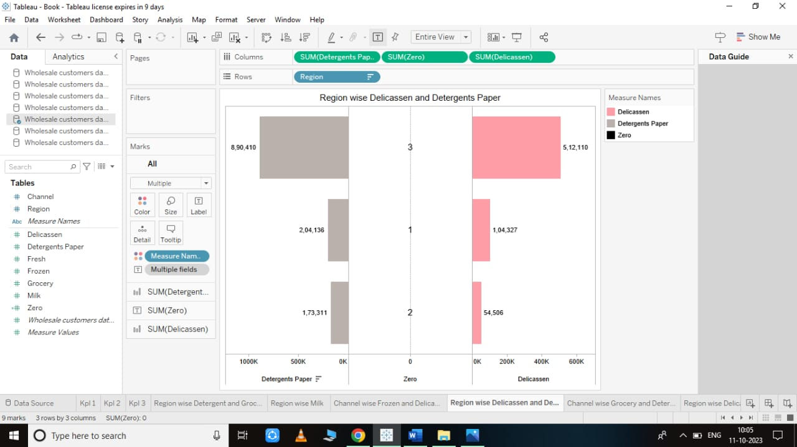

4.8 CHANNEL WISE GROCERY AND DETERGENT PAPER:

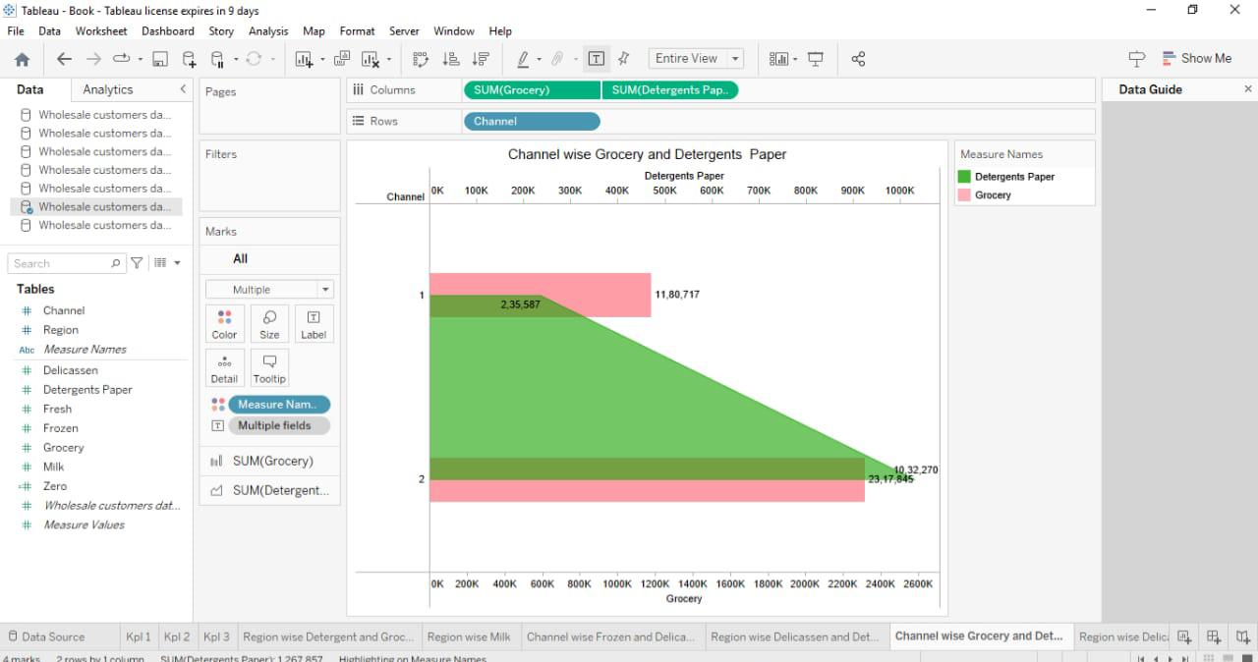

4.9 REGIO WISE DELICASSEN:

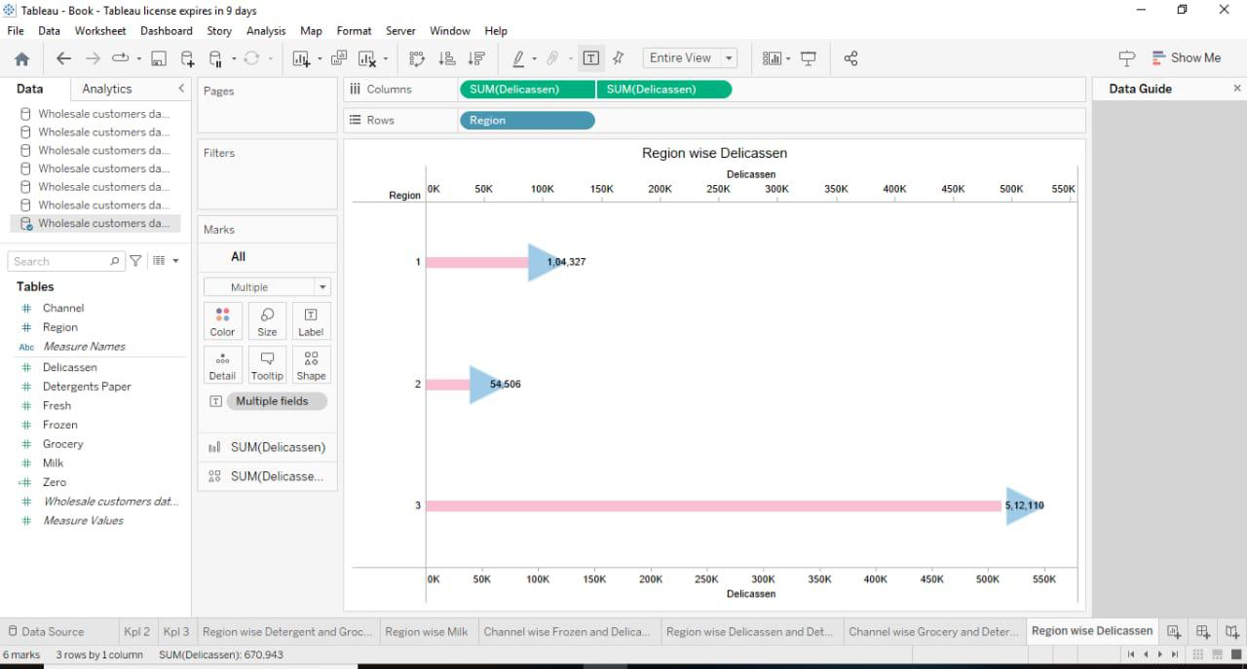

**5.RESULT:**

* 1. DASHBOARD:

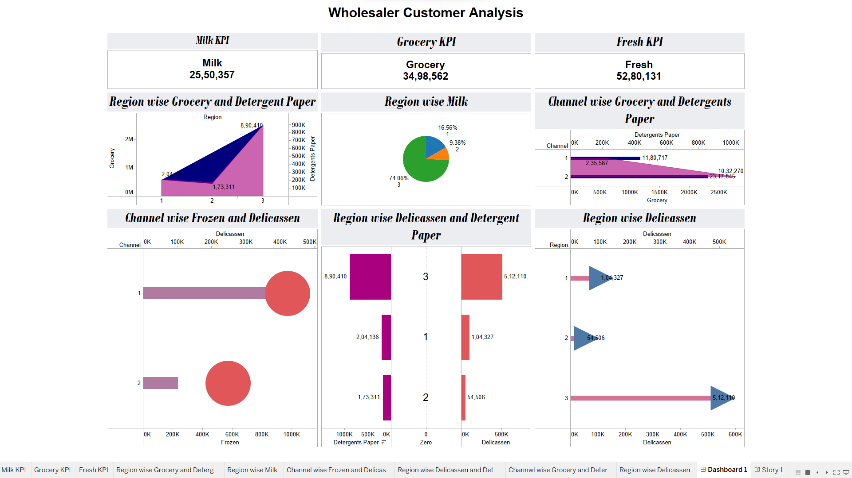

5.2 STORY:

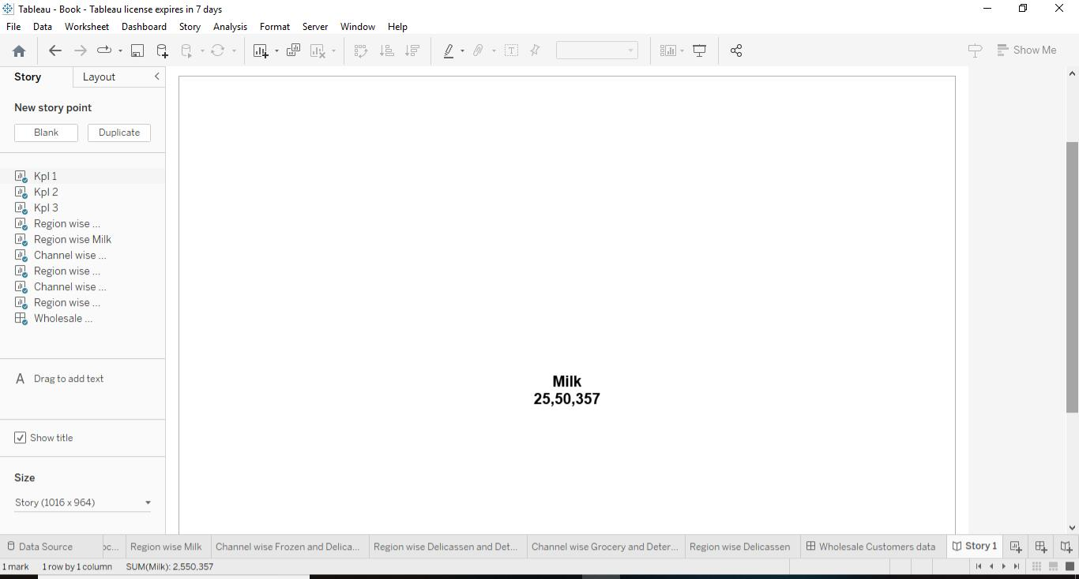

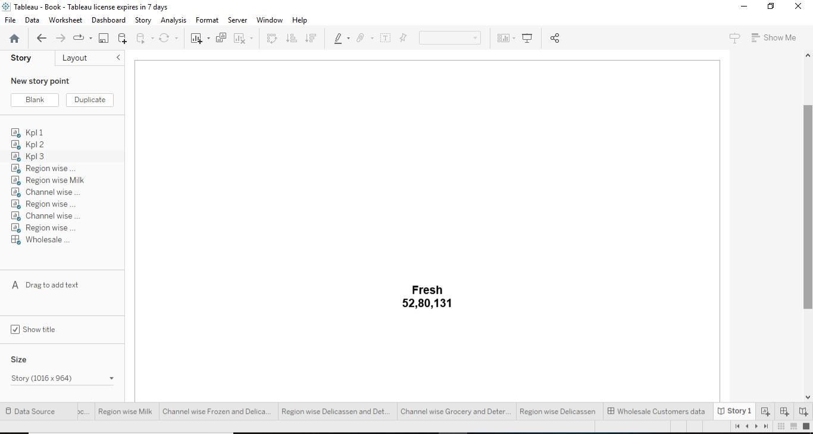



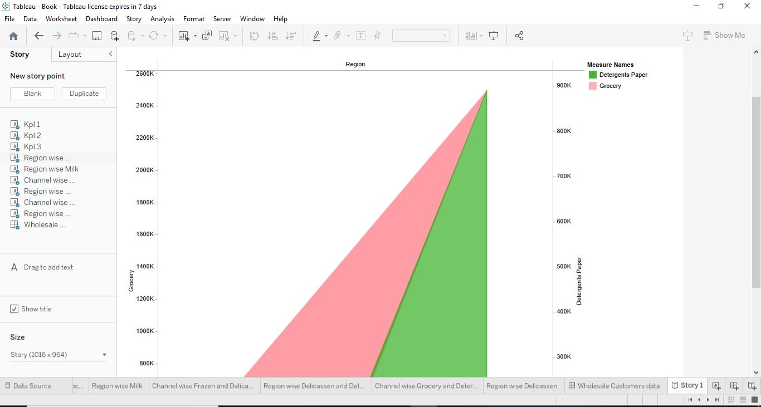

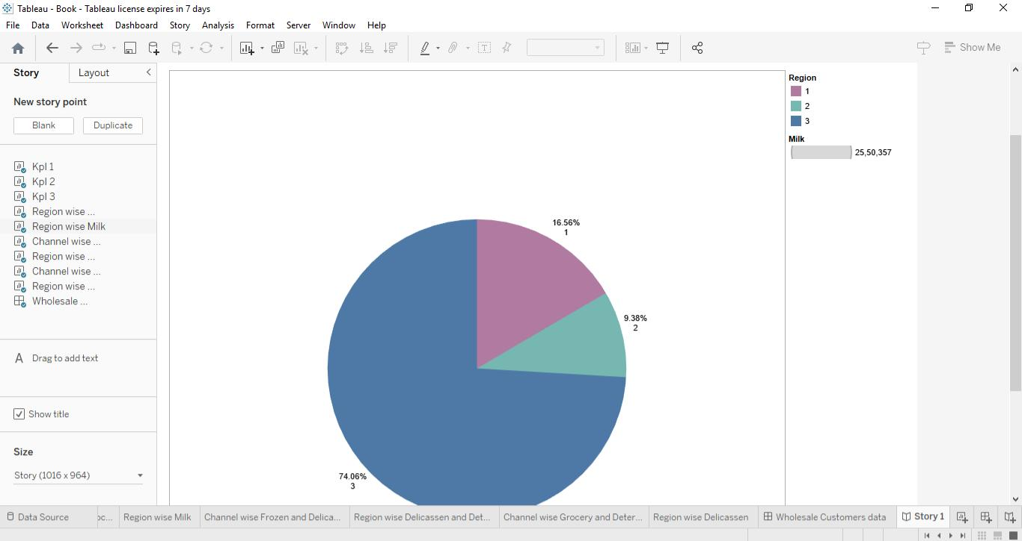

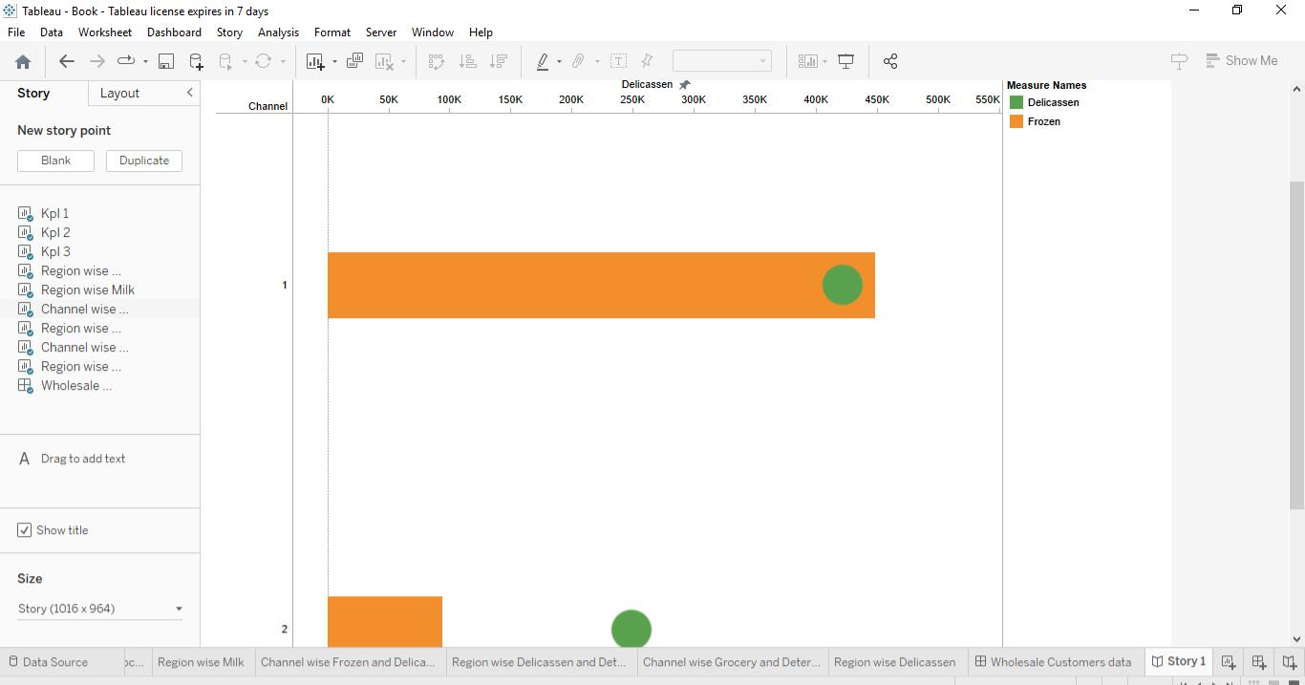

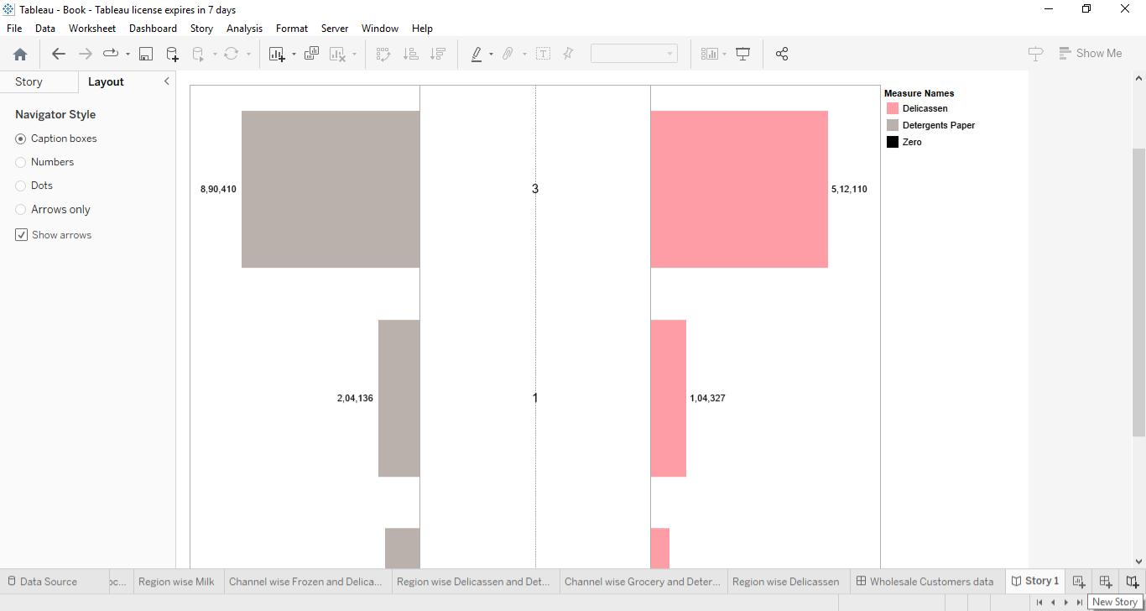

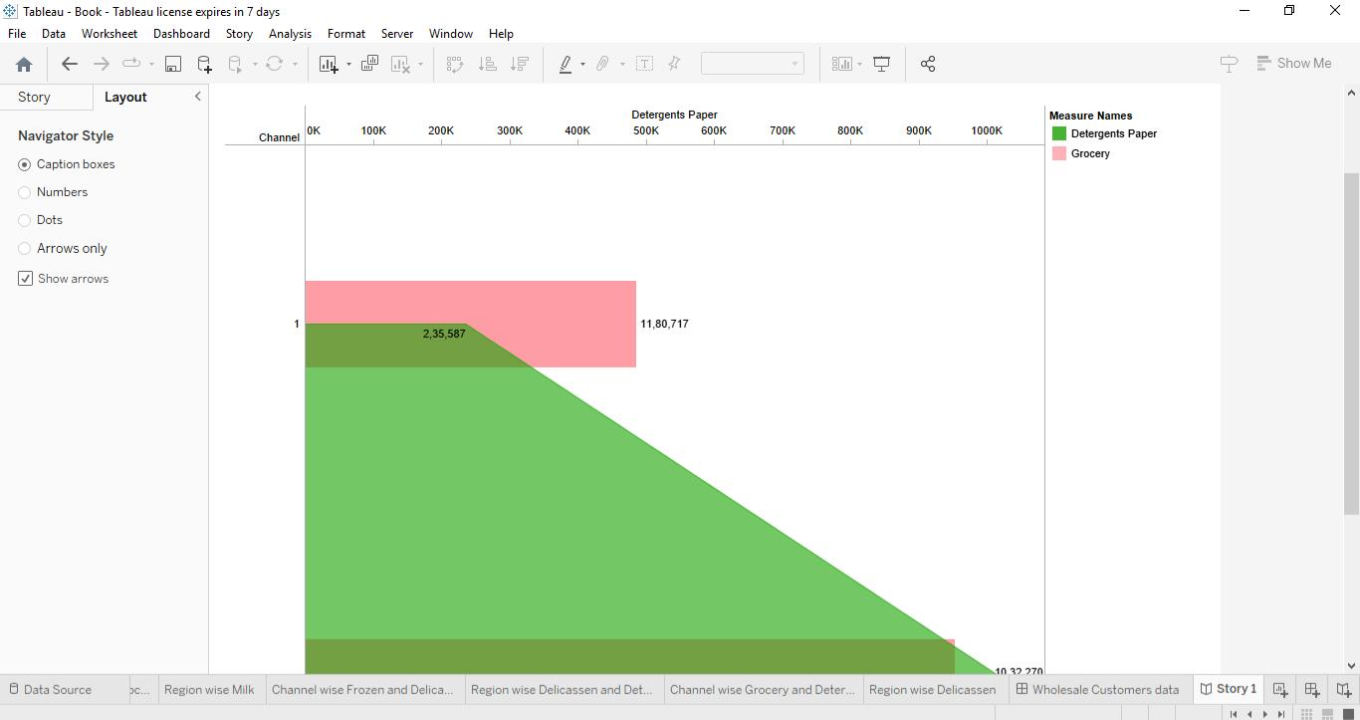

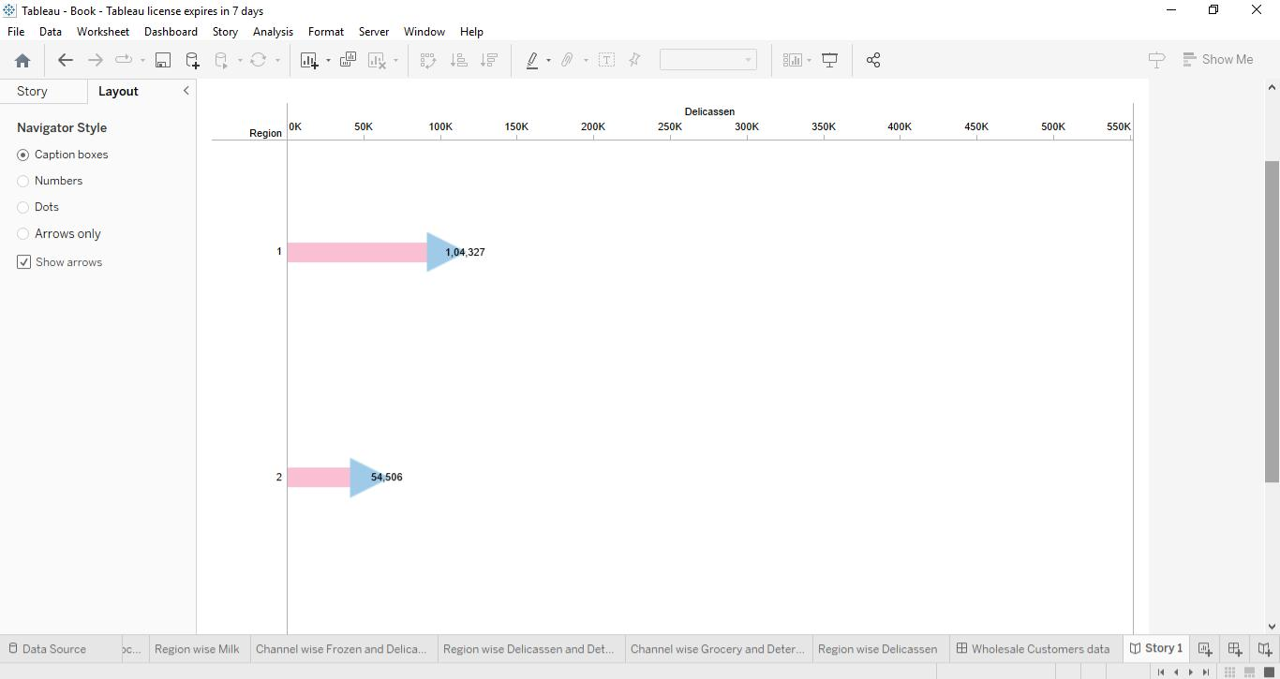

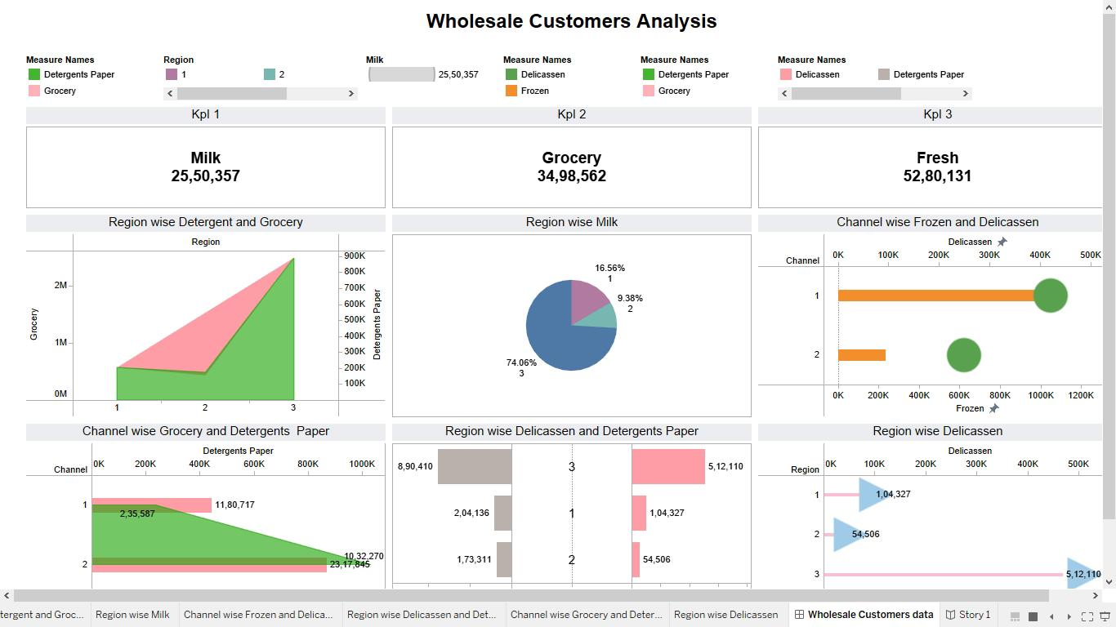

**6.PUBLICATIONS IN TABLEAU PUBLIC**

6.1Publication of Dashboard:

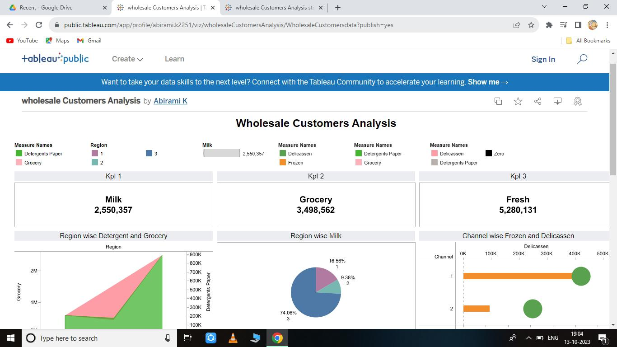

6.2Publication of Story:

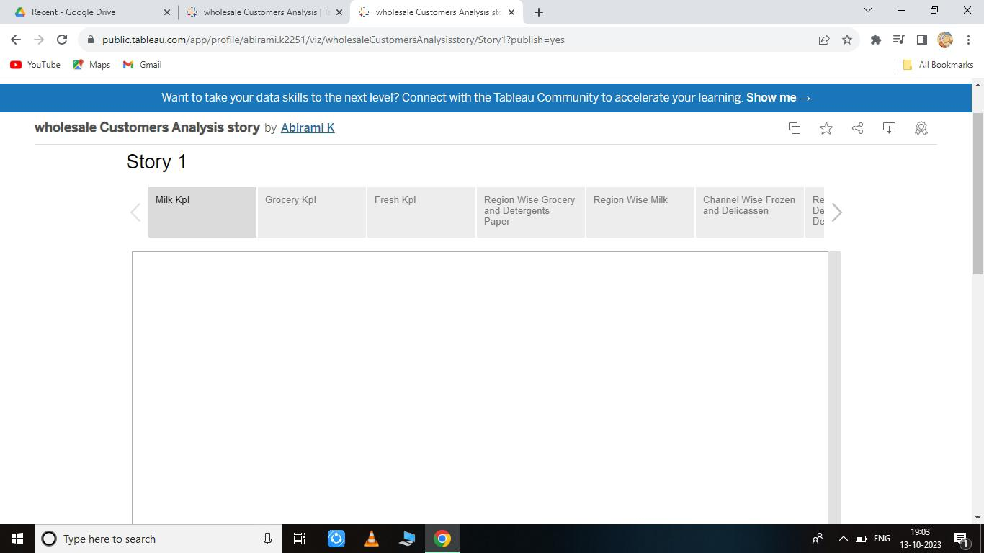

**7.ADVANTAGES AND DISADVANTAGES**

**Advantages:**

* Customer Satisfaction: By aligning products and services with consumer preferences, companies can enhance customer satisfaction and loyalty.
* Innovation: Market insights can inspire product innovation and the development of new services to meet evolving customer needs.
* Revenue Growth: Leveraging market insights can lead to increased sales and revenue, as businesses align their strategies with market demand.
* Cost Reduction: Understanding market dynamics allows companies to cut costs in less profitable areas and invest in more promising opportunities.
* Long-Term Success: Continuous analysis of market insights supports long-term success by adapting to changing market conditions and staying relevant.

**Disadvantages:**

* Data Privacy Concerns: Gathering detailed market insights often involves collecting sensitive customer data. The more you know about individual spending behaviors, the greater the risk of privacy breaches and data misuse. In many regions, there are strict regulations like GDPR in Europe or CCPA in California that require businesses to handle customer data carefully. Violating these regulations can result in legal and reputational consequences.
* Security Risks: Storing and managing market insights data requires robust security measures. Data breaches can lead to a loss of trust, financial penalties, and damage to your brand’s reputation. Cyberattacks are becoming increasingly sophisticated, making data security a constant challenge.
* Competitive Response: Sharing your market insights openly can invite competition to act on the same information. While competition is a natural part of business, revealing too much can potentially dilute your competitive advantage and make it harder to capitalize on growth opportunities.Data Quality and Bias: Market insights are only as good as the data they are based on. Incomplete or biased data can lead to erroneous conclusions. Biases in data collection can result from factors like sample selection, survey design, or data collection methods. Relying on flawed insights can lead to poor decision-making.
* Overwhelming Amount of Data: The availability of large datasets can sometimes lead to “analysis paralysis.” It’s easy to get lost in the sea of data and struggle to extract meaningful insights. This can be time-consuming and costly, as it may require significant resources to manage and analyze the data effectively.

**8.APPLICATIONS**

**Retail and E-Commerce:**

Personalized Marketing: Retailers can use spending behavior data to personalize marketing efforts, recommend products, and offer discounts tailored to individual preferences.

**Inventory Management:**

Insights can help optimize inventory levels and prevent overstocking or understocking of products

Financial Services:

**Risk Assessment:**

Banks and financial institutions can use insights to assess credit risk, detect fraudulent activities, and provide personalized financial services to customers.

**Investment Opportunities:**

Investors can make informed decisions based on market insights, identifying growth opportunities and potential risks.

**Healthcare:**

Patient Care: Healthcare providers can use insights to understand patient behavior, improve treatment plans, and predict disease outbreaks.

**Pharmaceutical Research:**

Insights can guide pharmaceutical companies in identifying unmet medical needs and developing new drugs.

**9.CONCLUSION**

* By understanding consumer behavior and emerging market trends, businesses can proactively identify growth opportunities, innovate, and stay ahead of the competition.
* Manage Risk: Insights enable businesses to assess risks, detect fraud, and make prudent financial decisions.
* Contribute to Economic Growth: Governments and public policy makers can leverage market insights to shape economic policies, allocate resources effectively, and support overall economic growth.

**10. FUTURE SCOPE**

* Data Analytics and AI: The field will increasingly rely on advanced data analytics and artificial intelligence (AI) to process large datasets, identify patterns, and predict consumer behavior more accurately.
* Personalization: The focus on personalization will grow, with businesses tailoring their products and services to individual customer preferences through data-driven insights.
* E-commerce and Online Behavior: As e-commerce continues to expand, understanding online spending behavior and optimizing digital marketing strategies will be vital